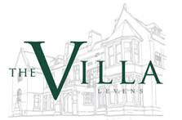

Wines & Foods of Portugal
12 April 2019
Canapes
Areal Rose – Quinta da Pousada – Vinho Verde

Bacalao Fritter, Condensed Milk, Egg & Olives
Parcelas Branco – Quinta de Porrais – Duoro Valley

Pork & Clams, Alentejana, Potato & Garlic
Cacada Real – Tinto – Qunito Boavista – Alentejano

Chanfana of Goat Leg, Seared Rump, Fermented Cabbage
Monte de Cacada – Quinta Boavista – Alentejano

Selection of Portuguese Cheese with Bread,
Honeycomb/Palm Sugar & “Jam”
Portas de Luz – Tinto – Quinta Boavista – Algarve



