

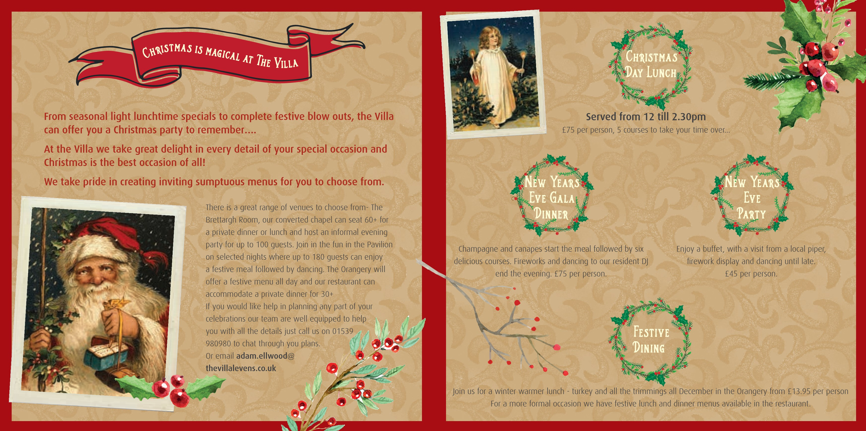







**Booking Conditions**

**A non-refundable deposit of £500 per room is required to secure your booking. We also ask for full pre-payment by 1st**

**December 2015. In the unfortunate event that you need to cancel your reservation, we reserve the right to charge in full if**

**the cancelled room(s) remain unsold. We there¬fore strongly recommend that you take out insurance to cover against any**

**unforeseen circumstances. We reserve the right to change the Christmas programme.**

**Don’t forget we offer Villa vouchers – a great gift idea!**

**The Villa Levens**

**Levens by Kendal**

**The English Lake District LA8 8EA**

**www.thevillalevens.co.uk**

**01539 980980**

Call 01539 980980 to book